LIE DETECTOR

AJITHA1, MOUNISHA2, PRANAY3

CHAITANYA BHARATHI INSTITUE OF TECHNOLOGY(A)

Email: [ajithagollapudi2003@gmail.com](mailto:ajithagollapudi2003@gmail.com),

[mounishashaik47@gmail.com](mailto:mounishashaik47@gmail.com), [pranaypranay180@gmail.com](mailto:pranaypranay180@gmail.com),

INTRODUCTION :

The Polygraphic Recorder, known as lie detector, since it records physiological changes of a subject under test. Various changes in parameters such as respiration rate, electrocardiograph, blood pressure, galvanic skin resistance are used to interpret the percentage of lying by the subject. The purpose of this study is to investigate the physiological responses while the subject is lying. When we lie, our blood pressure goes up, our heart beats faster, we breathe more quickly and changes take place in our skin moisture. A Lie Detector v1.0 and three software by evaluating, examining, calculating and observing, an examiner can tell from those mechanical scribbles whether or not you have spoken the truth.

* Lie detection is the practice of attempting to determine whether something is lying
* Usually this involves asking the subject the subject control questions where the answers are known to the examiner and comparing them to questions where the answers are not known.

COMPONENTS USED:

* ARDUINO UNO
* BREAD BOARD
* LEDS
* BUZZER
* SERIAL MONITOR AND PLOTTER
* JUMPER WIRES
* RESISTOR.(1K OHM)
* USB CABLE.

CIRCUIT SCHEMATICS:

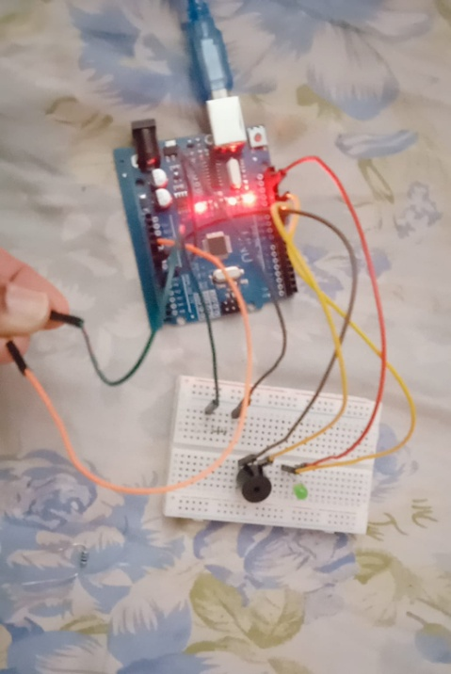

CODE :

13 pin of Arduino is connected to led and 12 to buzzer

void setup() {

Serial.begin(9600);

pinMode(13,OUTPUT);

pinMode(12,OUTPUT);

}

void loop() {

// put your main code here, to run repeatedly:

Serial.println(analogRead(A0));

delay(20);

if(analogRead(A0)>100)

{

digitalWrite(13,HIGH);

digitalWrite(12,HIGH);}}

PROCEDURE :

* INTERFACE LED AND BUZZER WITH ARDUINO USING BREADBOARD
* CONNECT THE CIRCUIT USING JUMPER WIRES AND CABLES
* ATTACH 1K RESISTOR WITH ANALOG PIN A0 OF ARDUINO UNO
* KEEP OTHER LEG OF RESISTOR TO INDEX FINGER
* SIMILARLY,TAKE OTHER JUMPER WIRE AND CONNECT IT TO 5V POWER PIN OF ARDUINO
* OTHER END OF THE WIRE SHOULD TOUCH MIDDLE FINGER.
* UPLOAD APPRORIATE CODE INTO ARDUINO UNO
* FROM THE TOOLS ARDUINO IDE ,GO TO SERIAL PLOTTER AND ANALYSE THE GRAPH WILL BE PLOTTED ACCORDING TO THE ANALOG VALUES.
* WHEN ANALOG VALUES AND GRAPH REACH CERTAIN PEEK ,LED GLOWS AND BUZZER STARTS PRODUCING BEEP SOUNDS INDICATING FALSENESS OF EVIDENCE.

OUTPUT:

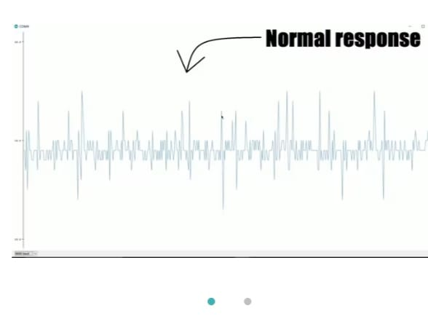

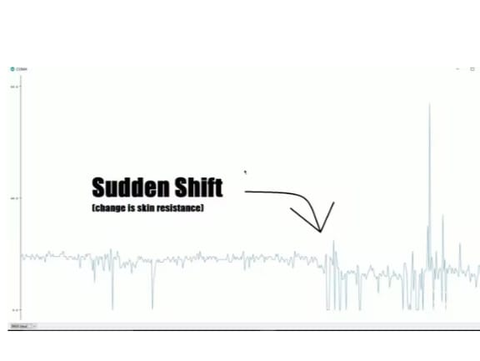

CONCLUSION:

This lie detector may lack accuracy but it’s a start to a bigger and better project by analysing and updating the process and code It lacks constitutional and scientific validity.Its not only used for humans to test whether they is saying the truth or lie but also has some more uses .

APPLICATIONS:

* Detecting if a person is telling the truth or not.
* Quantifying Tradeoffs
* Tradeoffs with suspicious thresholds
* Making Tradeoffs
* Improving scoring and interpretations
* Quality control
* Computerized scoring